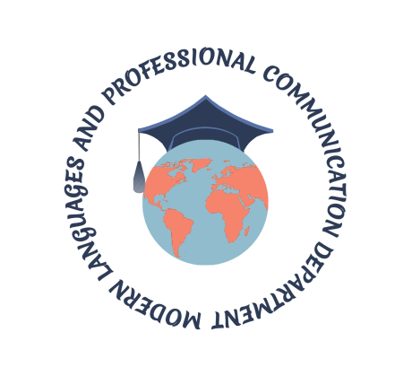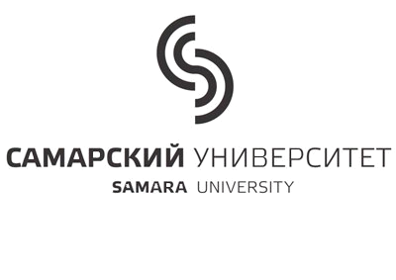
Visit Summer Institute at Samara National Research University
3 – 14 June 2017
Are you on the top of the “game”? Are you prepared to communicate your brilliance to the world? A panacea awaits you in one of the leading Universities in Russia.
Samara University opens Summer Institute “Developing Academic Writing Skills” in June, 2017. We warmly invite you to the opportunity to attend classes, seminars, workshops devoted to the most topical areas of academic writing in English. You will benefit immensely from the chance to do practical exercises, development and discussion your research projects with great Russian and foreign experts! All participants will take part in the International conference “Moving Forward in a Dynamic World” together with Russian, American, British, and Canadian experts, academics and practitioners from schools and universities.
Participation in the Summer Institute is a wonderful opportunity to enjoy the atmosphere of academic studies and to master writing and presentation skills. Moreover, a Boat Trip along the river Volga, and City Tour around old beautiful city will be an inclusive highlight.
Every participant attending Summer Institute receives a certificate of accomplishment for academic credit (72 hours – 2 credits). We encourage you to explore your study options at Samara’s premier university.
EVENT DETAILS
Date: 3 – 14 June 2017
Venue: Samara University
Address: 34, Moskovskoye shosse, Samara, 443086, Russia
Tel.: +7 (846) 334-57-22;
web: http://ssau.ru
We look forward to seeing you in June
Kind regards,
Victoria Levchenko
Chair of Modern Languages and Professional Communication Department
Samara University
Contacts Summer Institute:
Modern Languages and Professional Communication Department
Tel.: +7(846)334-54-54
kafedra_ino@mail.ru
Program coordinator: Svetlana Menshenina
Tel.: +7927-200-31-96
menshenina.mail@mail.ru

